Ikyo Expenses Claim and Approval System

User Guide (End-user)

1.1.0-20250604

Revision History

|  |  |  |  |
| --- | --- | --- | --- |
| **Version** | **Name** | **Reason For Changes** | **Date** |
| 1.0.0 | ikyo.org | Initial Revision. | 2025-05-26 |
| 1.1.0 | ikyo.org | 1. Updated *ES101 - Expense Report* function. 2. Add new function *ES102 - Cash Advancement Report*. | 2025-06-04 |
|  |  |  |  |
|  |  |  |  |
|  |  |  |  |
|  |  |  |  |
|  |  |  |  |
|  |  |  |  |
|  |  |  |  |
|  |  |  |  |
|  |  |  |  |

Approved By

Approvals should be obtained for project manager, and all developers working on the project.

|  |  |  |  |
| --- | --- | --- | --- |
| **Name** | **Signature** | **Department** | **Date** |
|  |  |  |  |
|  |  |  |  |

1. .

Table of Contents

1 Functionality 6

1.1 Screens 6

1.1.1 Menus 6

1.1.2 Overview 7

2 Initial Data Setup 8

2.1 Users 8

2.2 Groups 8

2.3 Currency 9

2.4 Office 9

3 Initialize and Configure 10

3.1 ES001A - Payment Method 10

3.2 ES001B - Payee 11

3.3 ES001C - Finance 12

3.4 ES001D - Approver 13

3.5 ES001E - Petty Expense 14

3.6 ES001F - User Roles 15

3.7 ES001G - Settings 16

3.8 ES003 - Expense Category 17

4 Expense Status 18

5 Workflow of Claimer 19

5.1 Roles 19

5.2 Flow of the Claim 19

5.2.1 Expense Claim 19

5.2.2 Cash Advancement 19

5.3 Inbox & Email Notify 20

6 Expense Claim 21

6.1 ES002 - Select Office 21

6.2 ES004 - New Expense Details 22

6.2.1 Upload Pages 23

6.2.2 Add Expense Items 25

6.2.3 Fill in Application Form 26

6.2.4 Supporting Document 27

6.2.5 Submit Expense 28

6.2.6 Expense SN 29

6.3 ES005 - Expense Enquiry 30

6.3.1 Search Conditions 31

6.3.2 Expenses Table 31

6.3.3 Expense Detail Information 31

6.3.4 Activity Table 31

6.4 Cancel Expense 32

6.5 Approve/Reject Expense 33

6.5.1 Reject Expense 33

6.5.2 Approve Expense 34

6.6 Pay Expense 35

6.6.1 Reject Expense 37

6.6.2 Settle Expense 37

6.7 Revert Settled Expense 37

7 ES006 - Cash Advancement 39

7.1 Create Cash Advancement 41

7.2 Cancel Cash Advancement 42

7.3 Approve/Reject Cash Advancement 43

7.4 Pay Cash Advancement 44

7.5 Revert Settled Payment 46

7.6 Cash Advancement SN 47

7.7 Activity 47

7.8 Prior Balance 47

7.9 Petty Expense 48

8 Prior Balance Expense 49

9 Petty Expense 51

10 ES101 - Expense Report 53

11 ES102 - Cash Advancement Report 54

12 PO001 - Purchase Order 56

12.1 Overview 56

12.2 Function Area Description 56

12.2.1 Search Criteria Section 56

12.2.2 Status Legend 56

12.2.3 PO History Section 57

12.2.4 PO Detail 57

12.3 Usage Process 58

12.3.1 Create 58

12.3.2 Approve 60

12.3.3 Reject 62

12.4 Use Purchase Order 64

# Functionality

***Ikyo Expenses Claim and Approval System (ES)*** automates the expense claim process within the company in a centralized manner. As a claimer, actions that you can perform include:

1. *Expense claim* - Allow user to apply for expense claim. The claim needs to be approved by the approver, and then settled by the accountant.
2. *Apply for cash advancement* - Allow user to apply for cash advancement for future use. Again, it needs to be approved and settled by the approver and the accountant, respectively.
3. *Purchase order* - Management of the Procurement Request Process, including Quotation, Approval, and other related steps.

**Keywords**:

Expenses claim, cash advancement, purchase order and approval.

## Screens

### Menus



***ES*** → ***Settings*** → ***ES001A - Payment Method***

***ES*** → ***Settings*** → ***ES001B - Payee***

***ES*** → ***Settings*** → ***ES001C - Finance***

***ES*** → ***Settings*** → ***ES001D - Approver***

***ES*** → ***Settings*** → ***ES001E - Petty Expense***

***ES*** → ***Settings*** → ***ES001F - User Roles***

***ES*** → ***Settings*** → ***ES001G -*** ***Settings***

***ES*** → ***ES002 - Select Office***

***ES*** → ***ES003 - Expense Category***

***ES*** → ***ES004 - New Expense***

***ES*** → ***ES005 - Expense Enquiry***

***ES*** → ***ES006 - Cash Advancement***

***ES*** → ***ES101 - Expense Report***

***ES*** → ***ES102 - Cash Advancement Report***

***ES*** → ***PO001 - Purchase Order***

### Overview

|  |  |  |
| --- | --- | --- |
| # | Function | Description |
| 1 | ES001A - Payment Method | Set Up Payment Methods.  E.g. *bank transfer*. |
| 2 | ES001B - Payee | Manage payees. |
| 3 | ES001C - Finance | Set up finance staff. |
| 4 | ES001D - Approver | Set up approvers. |
| 5 | ES001E - Petty Expense | Set up petty cash payers. |
| 6 | ES001F - User Roles | Set user-specific permissions. |
| 7 | ES001G - Settings | System global settings. |
| 8 | ES002 - Select Office | Select current working office. |
| 9 | ES003 - Expense Category | Expense categories. |
| 10 | ES004 - New Expense | Create new expense. |
| 11 | ES005 - Expense Enquiry | Expense query and management page. |
| 12 | ES006 - Cash Advancement | Cash advancement application and management page. |
| 13 | ES101 - Expense Report | Expense reports. |
| 14 | ES102 - Cash Advancement Report | Cash advancement report. |
| 13 | PO001 - Purchase Order | Purchase order application and management page. |

Throughout the following sections, features may be referenced by either their full names (e.g., *ES004 - New Expense*) or their codes (e.g., *ES004*); both refer to the same function.

# Initial Data Setup

Before the demonstration, we need to pre-populate the system with some basic data to ensure a smooth and complete walkthrough.

Please configure according to your actual situation (including the subsequent ES system settings).

## Users

On the ***System*** *→* ***User Management*** page, create the following roles to demonstrate how the **Expense System (ES)** works.

|  |  |  |
| --- | --- | --- |
| # | Account | Description |
| 1 | admin | System administrator. |
| 2 | acct | Accounting. |
| 3 | james | Claimer. |
| 4 | john | Approver. |
| 5 | mary | Office admin. |

## Groups

On the ***System*** *→* ***User Group Management*** page, create the following user groups to differentiate the permissions associated with various user roles in the system.

| # | Group Name | Function & Access Rights | Users | Description |
| --- | --- | --- | --- | --- |
| 1 | Administrator | 1. System -> UsrMnt - User Management (W)  2. System -> UsrGrpMnt - User Group Management (W)  3. System -> ScreenDfn - Screen Definition (W)  4. ES -> Settings -> ES001A - ES001A - Payment Method (W)  5. ES -> Settings -> ES001B - ES001B - Payee (W)  6. ES -> Settings -> ES001C - ES001C - Finance (W)  7. ES -> Settings -> ES001D - ES001D - Approver (W)  8. ES -> Settings -> ES001E - ES001E - Petty Expense (W)  9. ES -> Settings -> ES001F - ES001F - User Roles (W)  10. ES -> Settings -> ES001G - ES001G - Settings (W)  11. ES -> ES002 - ES002 - Select Office (W)  12. ES -> ES003 - ES003 - Expense Category (W)  13. ES -> ES004 - ES004 - New Expense (W)  14. ES -> ES005 - ES005 - Expense Enquiry (W)  15. ES -> ES006 - ES006 - Cash Advancement (W)  16. ES -> ES101 - ES101 - Expense Report (W)  17. ES -> ES102 - ES102 - Cash Advancement Report (W)  18. System -> Office - Office (W)  19. System -> Currency - Currency (W)  20. ES -> PO001 - PO001 - Purchase Order (W) | 1. admin | System administrator. |
| 2 | ES - Accounting | 1. ES -> Settings -> ES001B - ES001B - Payee (W)  2. ES -> ES002 - ES002 - Select Office (W)  3. ES -> ES003 - ES003 - Expense Category (W)  4. ES -> ES004 - ES004 - New Expense (W)  5. ES -> ES005 - ES005 - Expense Enquiry (W)  6. ES -> ES006 - ES006 - Cash Advancement (W)  7. ES -> ES101 - ES101 - Expense Report (W)  8. ES -> ES102 - ES102 - Cash Advancement Report (W)  9. ES -> PO001 - PO001 - Purchase Order (W) | 1. acct | Finance staff. |
| 3 | ES - Users | 1. ES -> ES002 - ES002 - Select Office (W)  2. ES -> ES003 - ES003 - Expense Category (R)  3. ES -> ES004 - ES004 - New Expense (W)  4. ES -> ES005 - ES005 - Expense Enquiry (W)  5. ES -> ES006 - ES006 - Cash Advancement (W)  6. ES -> ES101 - ES101 - Expense Report (W)  7. ES -> ES102 - ES102 - Cash Advancement Report (W)  8. ES -> PO001 - PO001 - Purchase Order (W) | 1. james  2. john  3. mary | Normal users. |

**Notes:**  
The letters “R” and “W” are abbreviations representing screen access rights:  
 **R**: Read - the user can view data but cannot modify it.  
 **W**: Write - the user can create, modify, or delete data.

## Currency

On the ***System*** *→* ***Currency*** page, add the currency. We will use **USD** for the demonstration; other currencies follow a similar process.



## Office

On the ***System*** *→* ***Office*** page, add some offices. We will use **Washington, D.C.** for the demonstration.



# Initialize and Configure

Before using the ES system, the system administrator needs to preconfigure basic data such as expense categories, approvers, etc.

## ES001A - Payment Method

The system supports the following default payment methods. Finance staff must select a payment method and upload the payment receipt when making a payment.

To access the settings page, navigate to ***ES → Settings → ES001A - Payment Method*** 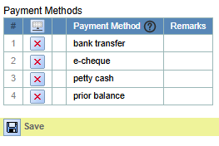

**The steps to add or edit a payment method are as follows:**

Modify the entries in the **Payment Method** table.

Click the **Save** button to confirm the changes.

The differences between the default payment methods are as follows:

|  |  |  |  |
| --- | --- | --- | --- |
| # | Payment Method | Payment No | Payment File |
| 1 | bank transfer | mandatory | optional |
| 2 | e-cheque | mandatory | mandatory |
| 3 | petty cash | optional | optional |
| 4 | prior balance | This field is mandatory if the expense payment amount exceeds 0. | This field is mandatory if the expense payment amount exceeds 0. |

## ES001B - Payee

Each expense and cash advancement requires a payee to be specified. The payee may be the claimer or another individual. Payee information is maintained in ***ES → Settings → ES001B - Payee***.

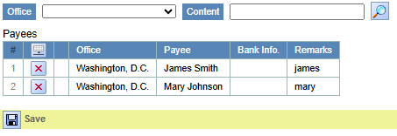

**The steps to add or edit a payee are as follows:**

Modify the entries in the **Payee** table.

Click the **Save** button to confirm the changes.

**Notes:**

The **Payee** is unique within each office.

**Bank Info** field is optional.

In the example, claimer ***James*** has **James Smith** as the payee, while the office petty admin **Mary** has **Mary Johnson** as her payee.

## ES001C - Finance

Each office is required to have at least one designated finance personnel. After an expense or cash advancement request is approved, the system will automatically notify the finance personnel to process the payment.

Office Finance information is maintained in ***ES → Settings → ES001C - Finance***.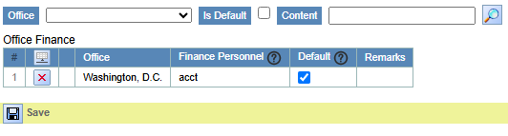

**The steps to add or edit a finance person are as follows:**

Modify the entries in the **Office Finance** table.

Click the **Save** button to confirm the changes.

**Notes:**

One finance personnel may be assigned to serve multiple offices.

If multiple finance personnel are assigned to an office, the system will notify all of them to carry out the next step in the process.

## ES001D - Approver

An approver must be designated for each expense or cash advancement submitted by the claimer. Approver information is maintained in ***ES → Settings → ES001D - Approver***. 

**The steps to add or edit an approver are as follows:**

Modify the entries in the **Office Approver** table.

Click the **Save** button to confirm the changes.

Below is an explanation of each column in the Approver table.

|  |  |  |  |
| --- | --- | --- | --- |
| # | Column | Require | Description |
| 1 | Office | Yes | The office(s) for which the approver is authorized to grant approvals. |
| 2 | Claimer |  | Claimer (optional):  If a specific approver needs to be assigned to a particular claimer, provide the claimer’s system account name in this field. |
| 3 | Claimer Group |  | Functions the same as the **Claimer** column, but allows specifying multiple claimers through a user group. |
| 4 | Approver | Yes | The approver's system account name. |
| 5 | Approver Group |  | The Approver Group functions the same as the **Approver** field, except it uses a user group to designate multiple approvers. |
| 6 | Approver Assistant |  | The **Approver Assistant** field is used to assign an assistant to the approver. An **Approver Assistant** has the same level of authority as the approver, and can approve any expense or cash advancement assigned to that approver. |
| 7 | Approver Assistant Group |  | *(Same as Approver Assistant).* |
| 8 | 2nd Approver |  | If an expense or cash advancement exceeds the threshold defined by **2nd Approver Min Amount**, a second approver is required. After the first approver approves, the system will notify the second approver. Finance staff will only proceed after the second approval is completed. |
| 9 | 2nd Approver Group |  | *(Same as 2nd Approve).* |
| 10 | 2nd Approver Min Amount |  | The minimum amount at which a second approver is required. |
| 11 | Enable | Yes | Indicates whether this setting is enabled. |

## ES001E - Petty Expense

In the ES system, the ***ES → Settings → ES001E – Petty Expense*** page is used to assign a petty admin for each office and to define the maximum allowable amount for petty expenses.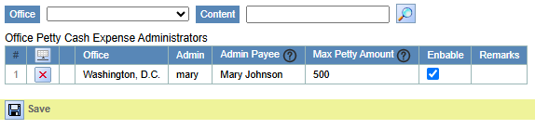

**The steps to add or edit a record are as follows:**

Modify the entries in the **Office Petty Cash Expense Administrators** table.

Click the **Save** button to confirm the changes.

Below is an explanation of each column in this table.

|  |  |  |
| --- | --- | --- |
| # | Column | Description |
| 1 | Office | The office(s) for which the petty administrator is authorized to grant approvals. |
| 2 | Admin | The **Admin** column specifies the system account of the petty administrator. Once a petty expense is approved, it proceeds to the next step, where it is forwarded to the petty administrator for payment processing. |
| 3 | Admin Payee | **Admin Payee** refers to the payee account name associated with the petty administrator. The petty administrator is required to receive a cash advancement before proceeding with the payment of petty expenses. |
| 4 | Max Petty Amount | The maximum amount a single claimer is allowed to claim for petty expenses. |
| 5 | Enable | Indicates whether this setting is enabled. |

## ES001F - User Roles

The User Roles page is primarily used to define viewing permissions, such as granting a user access to view expenses submitted by other users.

User Roles information is maintained in ***ES → Settings → ES001F - User Roles***.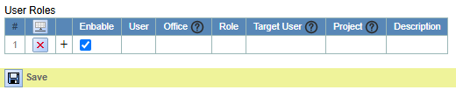

**The steps to add or edit a user role are as follows:**

Modify the entries in the **User Roles** table.

Click the **Save** button to confirm the changes.

Below is an explanation of each column in this table.

|  |  |  |  |
| --- | --- | --- | --- |
| # | Column | Require | Description |
| 1 | Enable | Yes | Indicates whether this setting is enabled. |
| 2 | User | Yes | The user’s system account. |
| 3 | Office |  | Specify office. |
| 4 | Role | Yes | The following are the user roles and their corresponding permissions:  **Admin**: Authorized to revert settled payments.  **Read Only**: Allowed to view expenses and cash advancements, but cannot make changes.  **Limited Access**: Restricted to viewing expenses and cash advancements of designated users; works in conjunction with the **Target User** column. |
| 5 | Target User |  | User’s system account name used for access restriction. |
| 6 | Project |  | The name of the expense item. The search is case-insensitive and supports wildcard characters such as * and ?. |
| 7 | Description |  |  |

## ES001G - Settings

The Settings page displays all global configurations of the system.

Settings information is maintained in ***ES → Settings → ES001G - Settings***.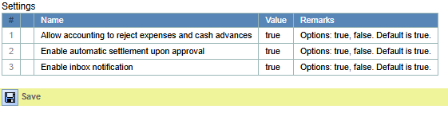

**The steps to modify settings are as follows:**

Modify the entries in the **Settings** table.

Click the **Save** button to confirm the changes.

Descriptions of each setting are listed in the table below.

|  |  |  |  |  |
| --- | --- | --- | --- | --- |
| # | Name | Values | Default | Description |
| 1 | Allow accounting to reject expenses and cash advances | true/false | true | If set to “true”, the accounting team is permitted to reject expenses and cash advancements. |
| 2 | Enable automatic settlement upon approval | true/false | true | This setting enables automatic settlement of expenses. For instance, petty expenses will be automatically marked as settled once approved by the petty administrator. |
| 3 | Enable inbox notification | true/false | true | Send messages to Inbox. |

## ES003 - Expense Category

The **Expense Category** page is used to define the specific types of each expense item, such as advertising, books, hotels, and so on. It is recommended that only system administrators be granted permission to modify this page, while regular users (e.g., claimers, approvers, and petty administrators) should be limited to view-only access.

**Expense Category** is maintained in ***ES → ES003 - Expense Category***. 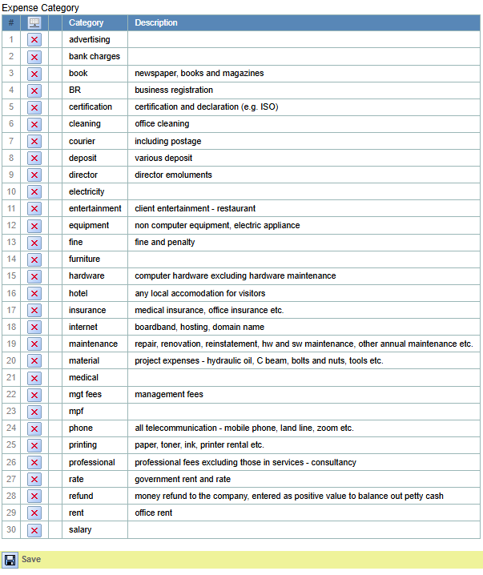

**The steps to modify categories are as follows:**

Modify the entries in the **Expense Category** table.

Click the **Save** button to confirm the changes.

# Expense Status

The following statuses are applicable to expenses and cash advancements:

|  |  |  |  |  |
| --- | --- | --- | --- | --- |
| # | Status | Operator | Next Status | Description |
| 1 | draft | Claimer | submitted | Represents the status before an expense is submitted by the claimer; intended for system backend use only. |
| 2 | submitted | Claimer | approved1  approved | This status indicates that the expense or cash advancement has been submitted by the claimer. The next step involves approval by the designated approver (including a second approver if required). At this stage, the claimer may cancel the request, and the approver has the option to reject it. |
| 3 | cancelled | Claimer | submitted | Indicates that the request has been cancelled by the claimer. Cancellation must occur before the approver has approved the request. |
| 4 | rejected | Approver  Accounting | submitted | Indicates that the request has been rejected by the approver. The claimer may revise and resubmit the request, or discard it entirely. |
| 5 | approved1 | Approver | approved  rejected | Indicates that the expense has received initial approval and is awaiting second-level approval. |
| 6 | approved | Approver  2nd Approver | settled  rejected | Indicates that the request has been approved by the approver (or second approver, if applicable). |
| 7 | settled | Approver  Petty Administrator  Accounting | approved | Indicates that the entire expense or cash advancement process has been completed.  When necessary, the administrator may use the “Revert Settled Payment” function to change a settled expense back to the “Approved” status. |

For morning, please reference to ***workflow.xlsx*** file.

# Workflow of Claimer

## Roles

There are three roles, namely,

1. *Claimer* - Person who applies for the claim.
2. *Approver* - Person who approves the claim, such as the manager.
3. *Petty expense administrator* - Petty Cash Administrator (e.g., Office Admin)
4. *Accountant* - Person who settle the claim by uploading payment records.

## Flow of the Claim

As a claimer, the staff can apply for expense claim to reimburse the receipt of purchase. Moreover, the claimer can apply for cash advancement for future purchase. Both actions need to be approved by the approver, and paid by the accountant.

### Expense Claim

The typical flow of an expense claim is as follow (*refer Section 6 for detail*):

1. The claimer creates the claim and submits the claim in ***ES004***.
2. The approver approves the claim in ***ES005.***
3. The accountant uploads the payment record in ***ES005***.
4. The claimer downloads the payment record in ***ES005***.

If no approver is designated in an office, reimbursement requests will be directly sent to the finance personnel for approval.

### Cash Advancement

The typical flow of applying cash advancement is as follow (*refer Section 7 for detail*):

1. The claimer applies cash advancement in ***ES006***.
2. The approver approves the cash advancement in ***ES006***.
3. The accountant uploads the payment record in ***ES006***.
4. The claimer downloads the payment record in ***ES006***.

If no approver is designated in an office, reimbursement requests will be directly sent to the finance personnel for approval.

## Inbox & Email Notify

Before creating anything, it is always a good practice to go to the ***Inbox*** to check the current status of your account.

The system sends an inbox message (as configured in ES001G - Setting) and an email notification to the user responsible for the next step in the workflow.

# Expense Claim

The Expense Claim process consists of the following steps:

***ES002 - Select Office*** – Select the office for which the expense claim is being submitted.

***ES003 - Expense Category*** – Review the available expense categories.

***ES004 - New Expense Details*** – Upload the required documents for the expense claim (e.g., invoices, contracts), fill in the necessary details (such as description, category, amount, etc.), and then submit the claim.

***ES005 - Expense Enquiry*** – View the status and result of the submitted claim, including approval, rejection, and payment information.

If Prior Balances need to be used for payment, a cash advancement must first be requested in **ES006 - Cash Advancement** before submitting the claim in **ES004**.

The following sections provide step-by-step instructions. For details regarding **ES006**, please refer to Chapter **7**.

## ES002 - Select Office

An office must be selected before creating each expense, since a user may be associated with multiple offices.

Settings information is maintained in ***ES → ES002 - Select Office***.

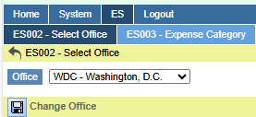

**The steps to modify the work office are as follows:**

In the **Office** field, select an office.

Then, click the **Change Office** button to save the selection.

## ES004 - New Expense Details

On this page, the claimer is primarily required to complete the following tasks:

**Upload expense documents**, such as invoices, contracts, etc.

At least one document is required per expense, but multiple documents can be uploaded.

**Fill in the claim items** based on the uploaded documents, including details such as reimbursement description, category, amount, project, etc.

**Enter additional expense information**, including payee, approver, and payment method.

To create a new blank expense, navigate to ***ES004 - New Expense Details*** from the menu.

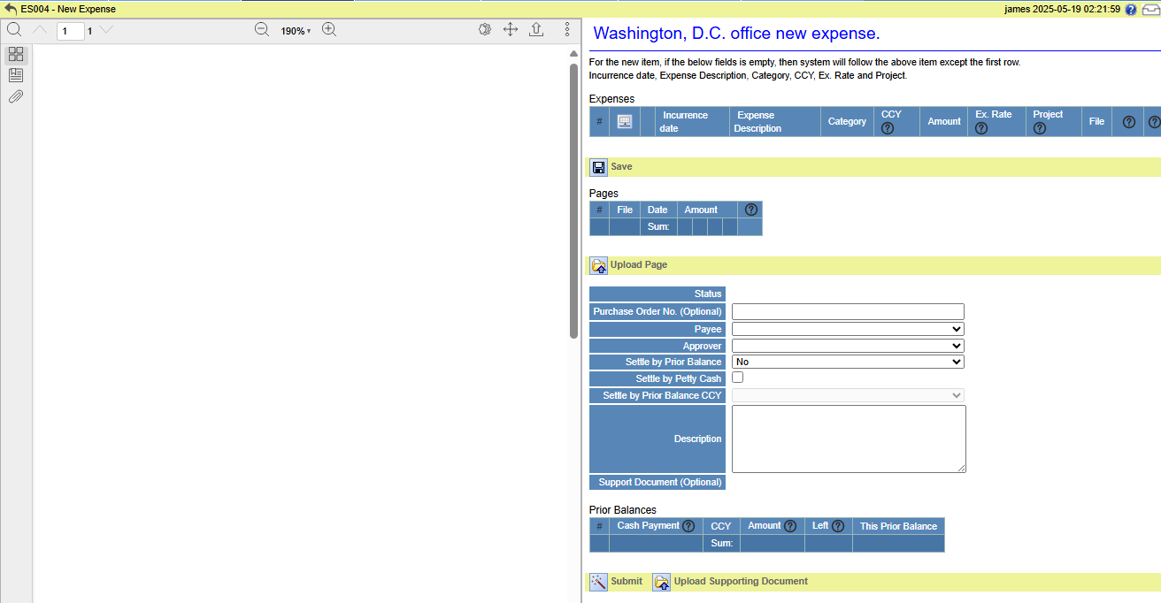

**Main layout of the page:**

**Left panel**: Displays the uploaded file.



**Right panel**: Expense details.

1. **Top section**: Current working office.



1. **Expense Table**: Table showing expense details.



1. **Save button**: Saves the Expense Table.



1. **Pages Table**: List of uploaded files.



1. **Upload Page button**: Button to upload a file.



1. **Expense Application Form**: Form for entering application details.

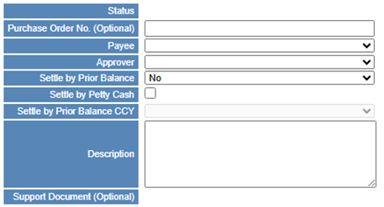

1. **Prior Balances Table**: Table showing available cash advancement balances.

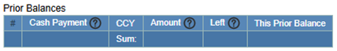

1. **Upload Supporting Document button**: Button to upload supporting documents.



1. **Submit button**: Button to submit the expense.



### Upload Pages

At least one supporting document (e.g., invoice, receipt, or contract) must be uploaded for each expense, as required by company policy. The system does not verify the actual content of the uploaded files.

**Please note the following when uploading files:**

Only files in PDF, PNG, JPG, or JPEG format are accepted.

Each file can only be uploaded once in the system.

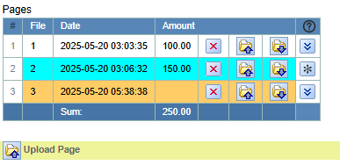

**The steps for uploading files are as follows:**

Click the **Upload Page** button to upload the receipt.



**Choose** a file and click the **Upload** button to upload it.

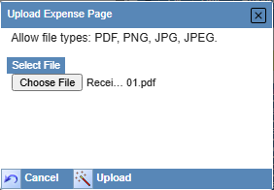

After a successful upload, a message will appear in the top message bar:

If the invoice has a hard copy, please write the sequence number 1 on the top right corner of the page and give it to the accounts department!

To upload more files, simply repeat steps *1* and *2*.

Uploaded files will be displayed in the **Pages** table.

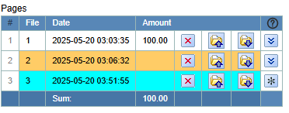

**Description of the Pages Table:**

**#:** Row number (e.g., 1, 2, 3).

**File:** Sequence number of the uploaded file. Each file uploaded within an office must have a unique number.

**Date:** The date and time the file was uploaded.

**Amount:** The total claimed amount in the uploaded file. Please reference to **Expenses** table.

: Delete the file.



http://localhost:8000/static/images/upload_button.gif: Re-upload the file (this will overwrite the previously uploaded version).

http://localhost:8000/static/images/download_button.gif: Download the file.

The file is downloaded using its sequence number as the file name.

Example: *1.pdf*.

: View the uploaded file. Button plugin icon indicates the file currently being viewed.



Row background color: Explanation of row colors is provided below.

1. **White background** indicates that the file has already been filled with expense details.



1. **Light orange background** indicates that the file has not yet been filled with expense details.



1. **Cyan (light blue) background** indicates that the file is currently being viewed.



### Add Expense Items

The Expense Table is used to enter details based on the uploaded file. A single file may contain one or more expense detail records. Each expense application (claim) must include at least one expense detail with an amount greater than 0.

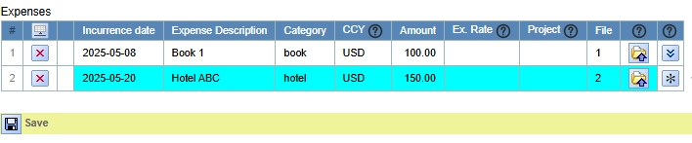

**Expense Table Column Description:**

#: Row number (e.g., 1, 2, 3).

**Incurrence Date**: The date the expense obligation was incurred (e.g., enter the date).

**Expense Description**: Description of the expense (e.g., enter the details).

**Category**: Expense category (e.g., select from the list).

**CCY**: Currency (optional). Defaults to the office's default currency as set by the administrator.

**Amount**: Expense amount (e.g., enter a value).

**Ex. Rate**: Exchange rate. It’s required when the selected currency (CCY) differs from the office’s default currency. Must be greater than 0.

**Project**: Project name (optional).

http://localhost:8000/static/images/upload_button.gif: Re-upload the file (this will overwrite the previously uploaded version).

This button is used to upload a new file and link the current expense row to it. This operation is different from uploading files via the Pages table.

plugin icon: View the uploaded file. Button plugin icon indicates the file currently being viewed.

Row background color: Explanation of row colors is provided below.

1. **White background** indicates that the file has already been filled with expense details.



1. **Light orange background** indicates that the file has not yet been filled with expense details.



1. **Cyan (light blue) background** indicates that the file is currently being viewed.



**The steps for add expense detail records are as follows:**

Click the insert button to add a new row.

Modify expense detail information

Click bttSaveExpenseDtl button to save the expense table.

Row background color: Explanation of row colors is provided below.

**Cyan (light blue) background** indicates that the file is currently being viewed.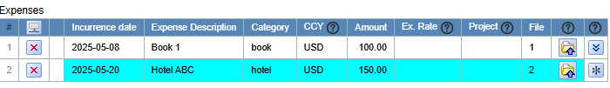

### Fill in Application Form

The Expense Application Form is used to provide key details for the expense, including the payee, payment method, and other related information.

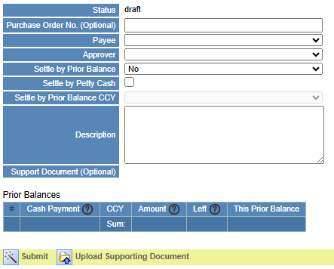

**Descriptions of the fields in the Expense Application Form:**

1. **Status:** The status of the expense (read-only). Before submission, the default status is **draft**. After submission, it may change to **cancelled** or **rejected**.
2. **Purchase Order No. (Optional)**: The purchase order number (optional). Refer to the **PO001 - Purchase Order** module for details.
3. **Payee**: The recipient of the payment (required). Select from a dropdown list showing all payees in the current office. When creating a new expense, the system will automatically select the payee used in the last submitted expense.
4. **Approver**: The person who approves the expense (required). Select from a dropdown list of available approvers for the current user. When creating a new expense, the system will default to the approver used in the last submitted expense.
5. **Settle by Prior Balance**: Indicates whether to settle the expense using prior balances. Options are **Yes** or **No** (default is **No**). If Yes is selected, you must specify the amount in the Prior Balances table.
6. **Settle by Petty Cash**: Indicates whether to settle the expense using petty cash. This option is only available if **Settle by Prior Balance** is No. The total expense amount must not exceed the maximum petty cash limit.
7. **Settle by Prior Balance CCY**: When settling with a prior balance and the currency differs from the office’s default, you can specify a different currency here. Once selected, the Prior Balances table will display available balances in that currency.
8. **Description**: A short description of the expense (optional).
9. **Supporting Document (Optional)**: Displays the filename of the uploaded supporting documents.

### Supporting Document

In the context of an expense system, supporting documents (such as invoices, receipts, or contracts) are used by finance staff to review and validate the submitted expense before approval and settlement. It’s optional.

**Key Points about Supporting Documents:**

1. Supporting documents are optional.
2. The approver can overwrite the supporting document submitted by the claimer in **ES005 - Expense Enquiry** before approval.
3. The claimer cannot view the supporting document in **ES005 - Expense Enquiry**, even if they were the one who submitted it.
4. An expense may include no more than one supporting document.
5. Only accept the PDF file.
6. **The uploaded supporting document will be automatically renamed.**  
   The format starts with **"S"**, followed by an 8-digit number. Each office maintains its own numbering sequence, starting from 1.  
   For example: ***S00000001.pdf***

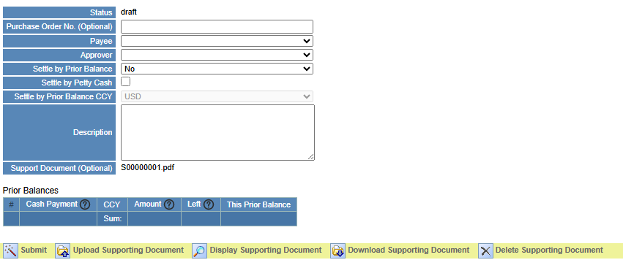

**Functions of the Supporting Document Buttons:**

1. **Upload Supporting Document**: Upload a supporting document.
2. **Display Supporting Document**: View the supporting document online. This button is only visible after a supporting document has been uploaded.
3. **Download Supporting Document**: Download the supporting document. This button is only visible after a supporting document has been uploaded.
4. **Delete Supporting Document**: Delete the supporting document. This button is only visible after a supporting document has been uploaded.

### Submit Expense

Once everything is ready, click the **Submit** button to submit the application. You can then check the approval and payment results in **ES005 - Expense Enquiry**. If needed, you can cancel the request in **ES005 - Expense Enquiry** and resubmit it. If the approver rejects the request, the rejection will also be visible in **ES005 - Expense Enquiry**, where you can edit and resubmit the application.

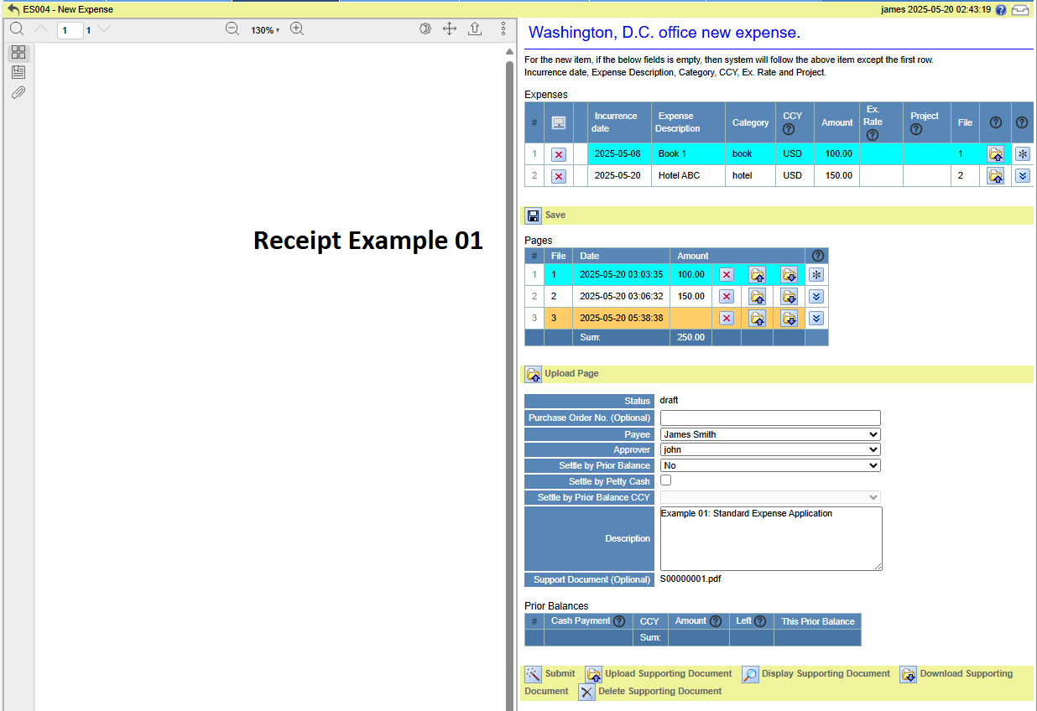

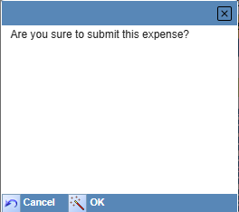

After clicking the **Confirm** button, a confirmation dialog will appear. Click **OK** to submit the application. Upon successful submission, the system will automatically open **ES005** from **ES004** and display the detailed information of the expense.

On the information page, the most important field is the SN (Serial Number), such as *WDC00000001* in the example below.

For details on the SN format, please refer to the next chapter.

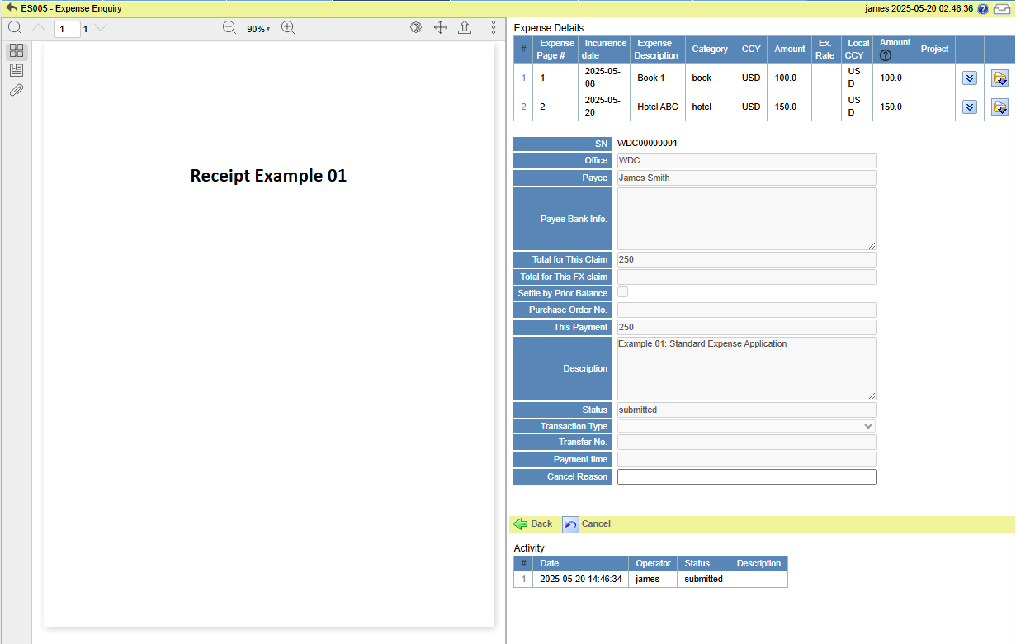

### Expense SN

Each office has its own independent and unique expense serial numbers (SN), such as WDC00000001.

The SN format consists of the office abbreviation (e.g., WDC) followed by an 8-digit number, starting from 1.

## ES005 - Expense Enquiry

**ES005** is primarily used for expense inquiry, approval, payment, and editing of cancelled or rejected expenses.

**The query results on this page must comply with the settings defined in ES001C, ES001D, ES001E, and ES001F.**

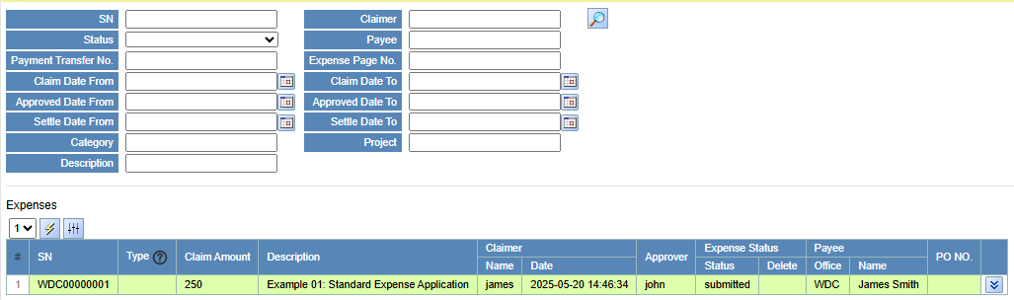

As shown in the figure above, the upper section of the page contains the search criteria, while the lower section displays the query results in a table.

The row background color and font color in the table are determined by the status of the expense. The mapping is as follows:

|  |  |  |  |
| --- | --- | --- | --- |
| # | Status | Display Style | Example |
| 1 | Submitted | Light green background |  |
| 2 | Cancelled | Dark brown background with white font |  |
| 3 | Rejected | Pink background |  |
| 4 | Approved | Bright blue background |  |
| 5 | Settled | Dark green background with white font |  |

**The figure below shows the expense detail information displayed after clicking the button.**  
The **left side** of the page is used to display the uploaded file, while the **right side** shows the detailed expense information along with the process history (Activity) of the expense (e.g., submission time, approval time, payment time, etc.).

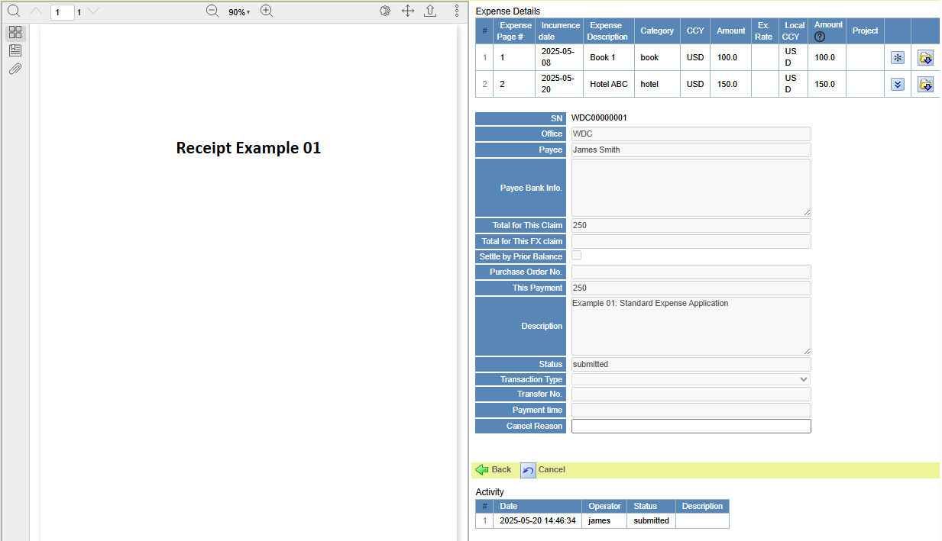

### Search Conditions

Unless otherwise specified, all search conditions use fuzzy matching and are case-insensitive.

### Expenses Table

**The Expense table lists key information about each expense, such as SN, claimer, amount, approver, etc.**  
The **Type** column indicates the type of expense. The descriptions are as follows:

1. FXE: Foreign Exchange Expense. Corresponds to selecting **Settle by Prior Balance CCY** in the Application Form in **ES004**.
2. PCE: Petty Cash Expense. Corresponds to selecting **Settle by Petty Cash** in **ES004**.

### Expense Detail Information

The expense detail page is similar to **ES004** and allows you to view all the information entered in **ES004**.

### Activity Table

The Activity table lists all actions performed on the current expense. Entries in this table are read-only and cannot be deleted or edited.

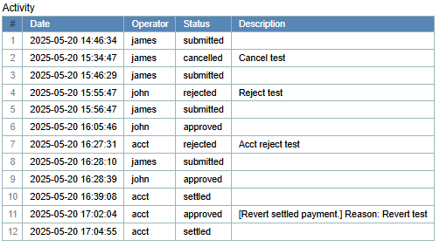

## Cancel Expense

**Only the claimer can cancel their own expense application, and only if it has not yet been approved or rejected.**

**Steps to Cancel an Expense:**

1. **In ES005, locate the expense you wish to cancel.**
2. **Click** plugin icon **to open the expense details.**
3. **Enter the Cancel Reason, then click the Cancel button.**

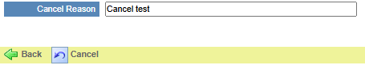

1. **Click OK to confirm.**

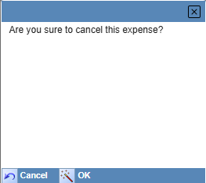

1. **Cancelled.**

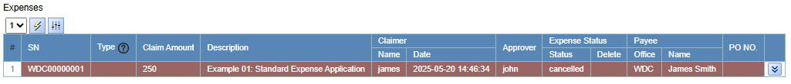

1. **If you need to make changes, click the Edit button, modify the details, and resubmit the expense in ES004.**

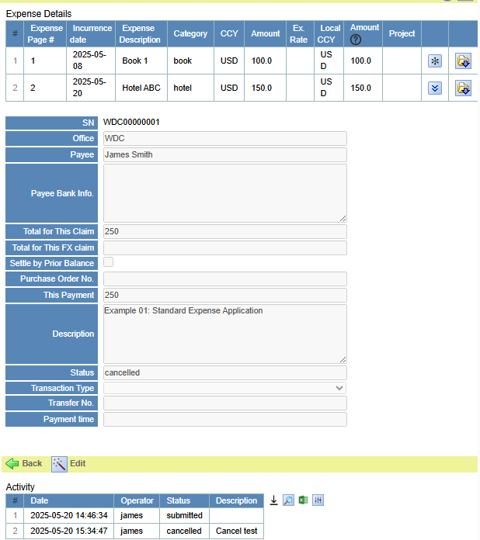

## Approve/Reject Expense

In **ES005**, approvers can view expenses that require their approval (including second-level approvals).

They can either approve or reject the expense, and may also upload a supporting document before approval, which will overwrite the one submitted by the claimer.

### ****Reject Expense****

Steps to Reject an Expense:

1. In **ES005**, locate the expense you wish to approve.
2. Click plugin icon to open the expense details.

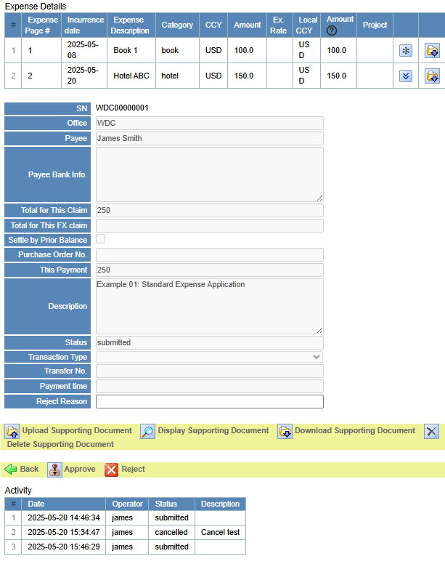

1. Enter the **Reject Reason**, then click the **Reject** button, then confirm the action by selecting **OK** in the confirmation dialog.

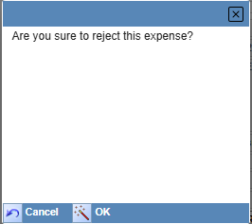

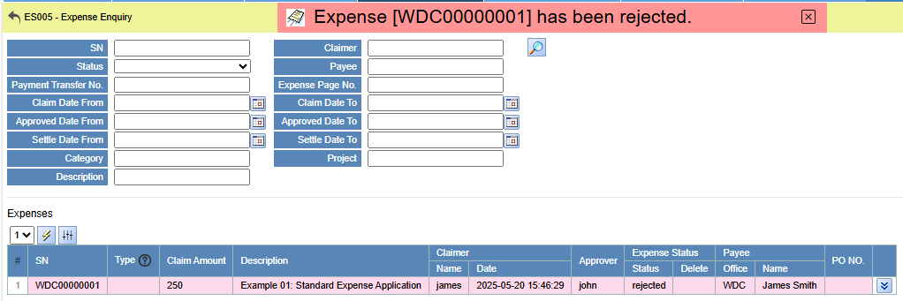

### Approve Expense

Steps to Approve an Expense:

1. In **ES005**, locate the expense you wish to approve.
2. Click plugin icon to open the expense details.

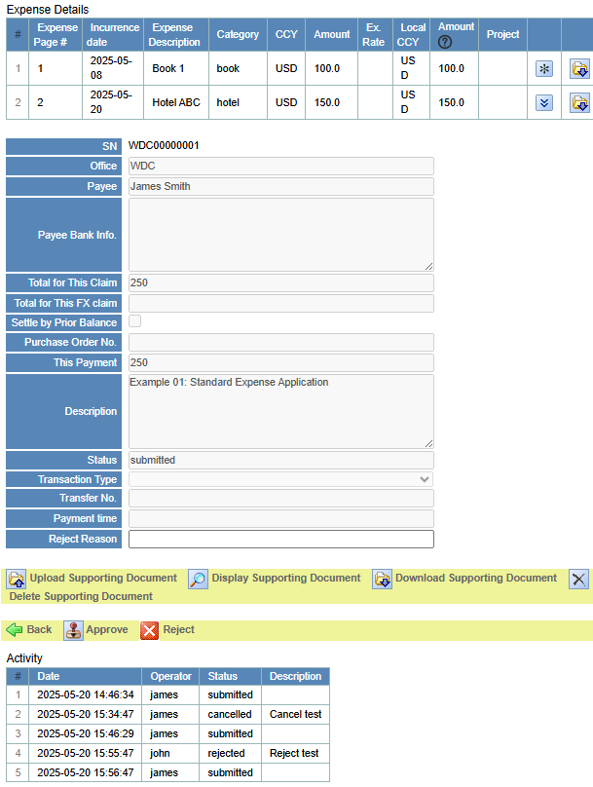

1. If necessary, click the **Upload Supporting Document** button to upload or replace the existing supporting document.
2. Click the **Approve** button, then confirm the action by selecting **OK** in the confirmation dialog.

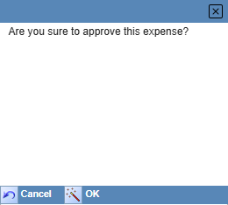

Once the approval is successful, the system will display a confirmation message such as: Expense [WDC00000001] has been approved.

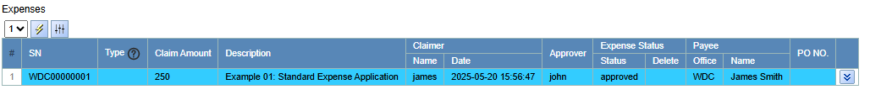

## Pay Expense

Once the approver has approved the request, the finance staff can handle the corresponding expense in **ES005** - this may include processing the payment or rejecting the expense if necessary.

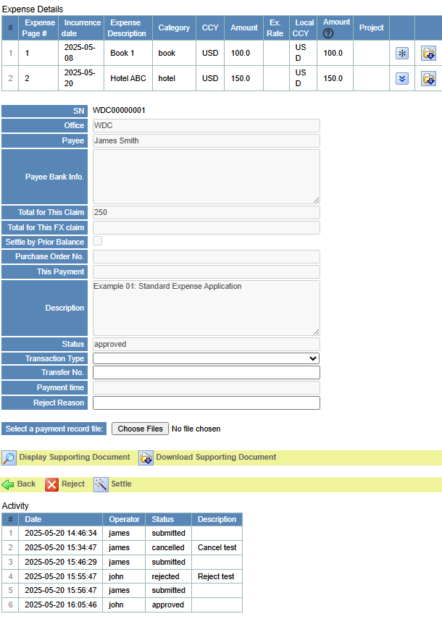

### Reject Expense

**Finance staff** (e.g., the acct account in this example) can reject an already approved expense.

The steps are the same as those for an approver: enter the **Reject Reason**, click the **Reject** button, and then confirm the rejection by clicking **OK** in the confirmation dialog.

### Settle Expense

After the finance staff processes the payment, the expense will be marked as settled. The steps are as follows (refer to **ES001A** for the relationship between steps 1, 2, and 3):

1. Select **Transaction Type** – This is mandatory.
2. **Transfer No.** – Enter the transfer number (e.g., bank transaction ID). This field is optional.
3. **Payment Record File** – Upload the payment record file. This is optional.

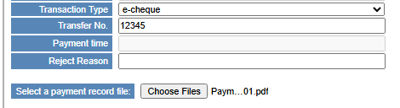

1. Click the **Settle** button.

Upon successful settlement, the system will show a confirmation message such as: *Expense [WDC00000001] has been settled.*

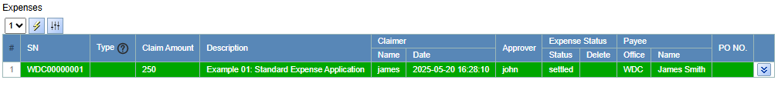

## Revert Settled Expense

If necessary, a settled expense can be reverted back to the Approved status. The steps are as follows:

1. In **ES001F - User Roles**, configure the users who are allowed to perform the **Revert Settled Expense** action (e.g., the *acct* account).
2. Check the **Enable** checkbox.
3. Enter the user name, e.g., *acct*.
4. Select the office.
5. Set the role to *Admin*.
6. Click Save.

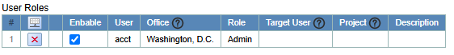

1. In **ES005**, open the Expense Detail of the expense to be reverted.

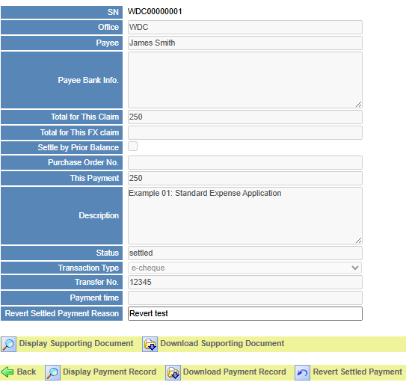

1. Enter the **Revert Settled Payment Reason**.
2. Click the **Revert Settled Payment** button, then confirm the action by clicking **OK** in the confirmation dialog.

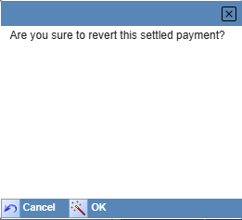

After a successful revert, a message like the following will be displayed: *Revert settled expense [WDC00000001] to approved.*

1. Once the revert is successful, the finance staff (such as the *acct* user) may proceed to either reject or settle the expense.

# ES006 - Cash Advancement

Cash Advancement allows claimers to request funds in advance for future expenses.

These funds can later be used to settle eligible expense claims, such as petty expenses, without requiring immediate reimbursement from the employee.

Cash Advancement is requested through the **ES006 - Cash Advancement** module.

The main operations include submission, approval, and payment. Similar to expenses, a cash advancement can also be cancelled or rejected.

The image below shows the main page of **ES006**.

The upper section is used for search criteria, and the lower section displays the search results in a table.

You can click  to view the detailed information of a cash advancement.

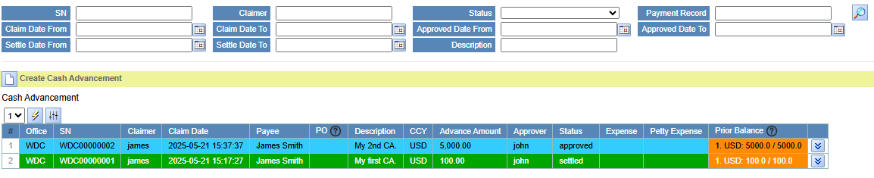



The row background color and font color in the table are determined by the status of the expense. The mapping is as follows:

|  |  |  |  |
| --- | --- | --- | --- |
| # | Status | Display Style | Example |
| 1 | Submitted | Light green background |  |
| 2 | Cancelled | Dark brown background with white font |  |
| 3 | Rejected | Pink background |  |
| 4 | Approved | Bright blue background |  |
| 5 | Settled | Dark green background with white font |  |
| 6 | Prior Balance greater than 0. | Orange background |  |

The columns in the **Cash Advancement** table clearly display relevant information about each cash advancement. The following columns are of particular note:

1. **Expense**: Lists the related Prior Balance Expenses by their serial numbers (SN).
2. **Petty Expense**: Lists the petty expenses associated with this cash advancement, also by serial numbers (SN).
3. **Prior Balance**: Shows the available balance in the format Currency: Balance / Total Amount.

If the balance is 0, the cash advancement can no longer be used for prior balance expenses or petty expenses.

When the background color is orange, it means the cash advancement still has available balance.

## Create Cash Advancement

A claimer can create a cash advancement by following these steps:

1. Open ***ES → ES006 - Cash Advancement*** from the menu.
2. Click the **Create Cash Advancement** button.



1. Fill out the **Cash Advancement Form**.

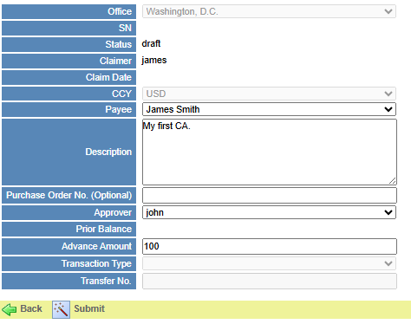

**Cash Advancement Form Field Descriptions:**

1. **Office**: The current working office, selected in **ES002**.
2. **SN**: Cash Advancement form serial number. Generated after submission.
3. **Status**: The status of the cash advancement, such as Submitted, Approved, or Settled. The default status is Draft before submission. This field is read-only.
4. **Claimer**: The account name of the person submitting the request.
5. **Claim Date**: The submission date. Automatically generated after submission.
6. **CCY**: The currency of the current office.
7. **Payee**: The recipient of the cash advancement. This field is required.
8. **Description**: A description of the cash advancement. This field is required.
9. **Purchase Order No. (Optional)**: The purchase order number. Refer to the **PO001** module.
10. **Approver**: The person responsible for approving the request. This field is required.
11. **Prior Balance**: Summary of prior balances. Automatically generated by the system.
12. **Advance Amount**: The amount requested. This field is required.
13. **Transaction Type**: The payment method. To be filled in by finance staff after approval.
14. **Transfer No.**: The payment reference number. To be filled in by finance staff after approval.
15. Click the **Submit** button.

Once submitted successfully, the status and other details of the cash advancement can be viewed in **ES006** *Cash Advancement* table.

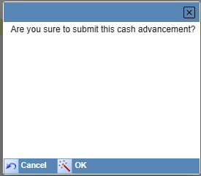

Upon successful submission, the system will display a confirmation message such as: Cash advancement [WDC00000001] submitted.

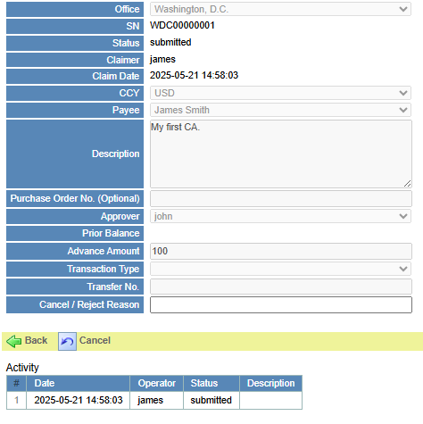

## Cancel Cash Advancement

If a cash advancement has not yet been processed (e.g., *approved* or *rejected*), the claimer can cancel the request. The steps are as follows:

1. In **ES006 - Cash Advancement**, locate the cash advancement record you want to cancel in the **Cash Advancement** table.



1. Click plugin icon to open the cash advancement details.
2. Enter the **Cancel Reason**, click the **Cancel** button, and confirm the action by clicking **OK** in the confirmation dialog.

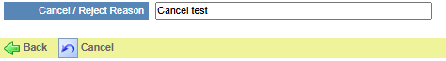

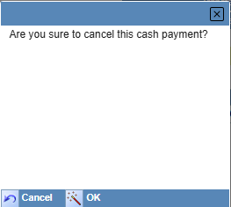

Upon successful cancellation, a message like the following will be displayed: Cash advancement [WDC00000001] has been cancelled.



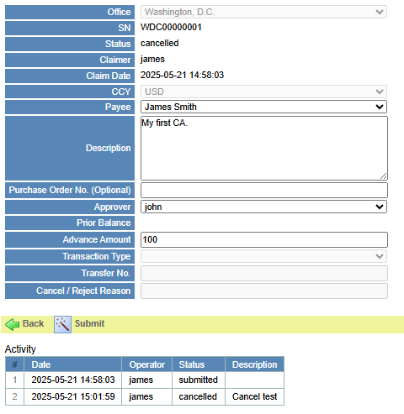

For cancelled cash advancements, the claimer can click the **Submit** button to make changes and resubmit the request.

## Approve/Reject Cash Advancement

Once the approver receives the request, they can either approve or reject the corresponding cash advancement. The steps are as follows:

1. In **ES006 - Cash Advancement**, locate the cash advancement record to be processed in the **Cash Advancement** table.



1. Click plugin icon to open the cash advancement details.

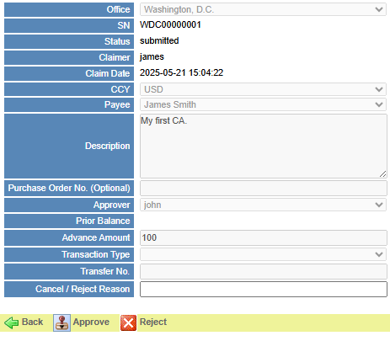

1. If the request needs to be rejected, first enter the **Reject Reason**, then click the **Reject** button, and confirm the rejection by clicking **OK** in the confirmation dialog.



For rejected cash advancements, the claimer can also click the **Submit** button to modify the request and submit it again.

1. If the request is acceptable, click the **Approve** button, then confirm the action by clicking **OK** in the confirmation dialog.



## Pay Cash Advancement

Once the finance staff (e.g., *acct* in this example) receives the approval notification, they can proceed with the payment. The steps are as follows:

1. In **ES006 - Cash Advancement**, locate the cash advancement record to be processed in the **Cash Advancement** table.



1. Click plugin icon to open the cash advancement details.

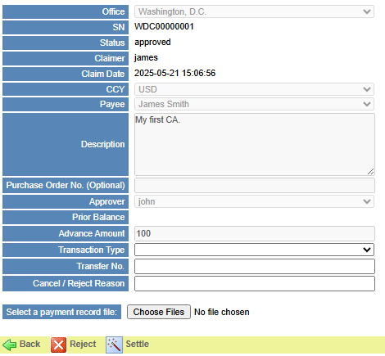

1. If the request needs to be rejected, enter the **Reject Reason**, click the **Reject** button, and confirm the action by clicking **OK** in the confirmation dialog.



1. If proceeding with the payment, fill in the **Transaction Type**, **Transfer No.**, and select the payment record file (refer to section **ES001A** for details).
2. Click the **Settle** button and confirm the action by clicking **OK** in the confirmation dialog.

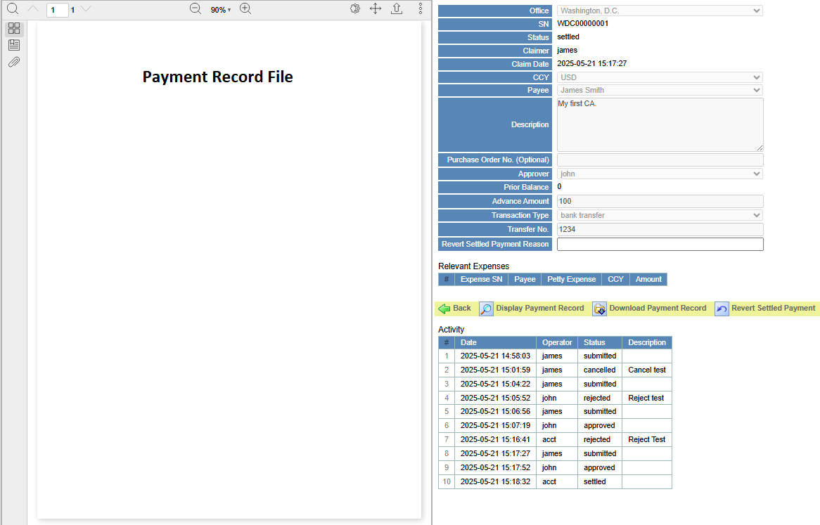



## Revert Settled Payment

If necessary, a settled cash advancement can be reverted back to the Approved status. The steps are as follows:

1. In **ES001F - User Roles**, configure the users who are allowed to perform the **Revert Settled Expense** action (e.g., the *acct* account).
2. Check the **Enable** checkbox.
3. Enter the user name, e.g., *acct*.
4. Select the office.
5. Set the role to *Admin*.
6. Click Save.



1. In **ES006**, open the detail of the cash advancement to be reverted.

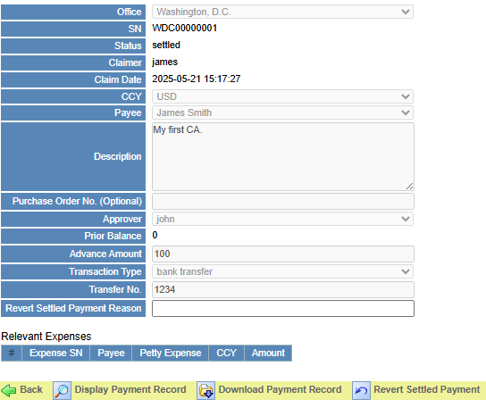

1. Enter the **Revert Settled Payment Reason**.
2. Click the **Revert Settled Payment** button, then confirm the action by clicking **OK** in the confirmation dialog.



After a successful revert, a message like the following will be displayed: *Revert settled cash advancement [WDC00000001] to approved..*

1. Once the revert is successful, the finance staff (such as the *acct* user) may proceed to either reject or settle the expense.

**Important:** A cash advancement cannot be reverted if it has already been used in a prior balance expense or petty expense.

## Cash Advancement SN

Each office has its own independent and unique expense serial numbers (SN), such as **WDC00000001**.

The SN format consists of the office abbreviation (e.g., WDC) followed by an 8-digit number, starting from 1.

## Activity

The Activity table lists all actions performed on the current cash advancement. Entries in this table are read-only and cannot be deleted or edited.

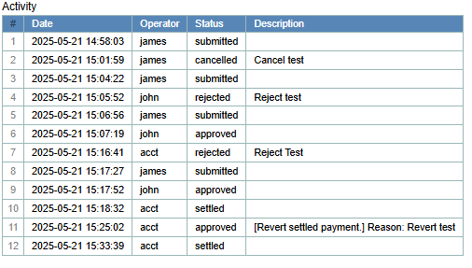

## Prior Balance

Cash advancements can be used as a settlement method (prior balance) when submitting an expense claim. In **ES006**, the related expense details for each cash advancement can be viewed.

Open the Cash Advancement Detail page to view the **Relevant Expenses** table, as shown in the example below.

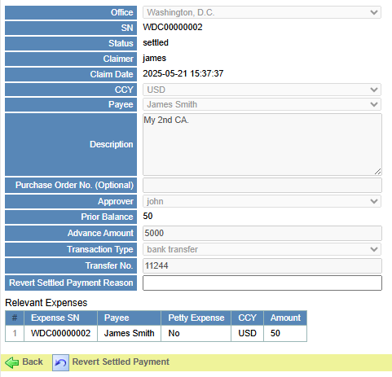

## Petty Expense

The petty administrator is allowed to settle petty expenses using cash advancement prior balances and can track the usage of those advances in **ES006**.





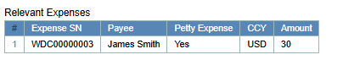

# Prior Balance Expense

When submitting an expense in **ES004**, the claimer can choose to settle it using the **Settle by Prior Balance** option.

The total prior balance amount may be less than or equal to the total expense amount.

If the prior balance amount is less than the total expense, the finance staff only needs to pay the difference (i.e., *expense amount - prior balance*).

**Steps to apply for a Prior Balance expense:**

1. Apply for a cash advancement in **ES006 - Cash Advancement**. Once it is settled, proceed to the next step.
2. Enter the expense details in **ES004 - New Expense Details**:
3. In the Expense Application Form, set **Settle by Prior Balance** to **Yes**.

Based on the Prior Balances table and the total expense amount, the system automatically calculates and fills in the prior balance amount for each cash advancement. The claimer may adjust these values as necessary.

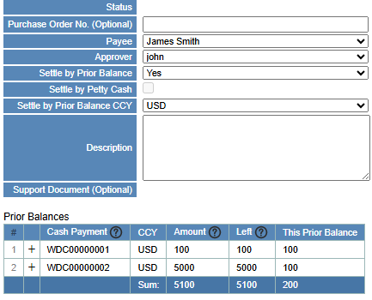

1. In the **Prior Balances** table, fill in the **This Prior Balance** amount.

**For demonstration purposes, we will change the "This Prior Balance" value of *WDC00000002* to 50.  
This means the finance staff will need to pay the remaining 50 to the claimer (200 - 150).**

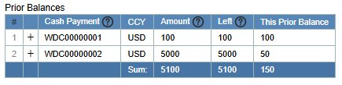

**Note:** The total applied prior balance must not exceed the total expense amount.

1. Click the **Submit** button to submit the expense.

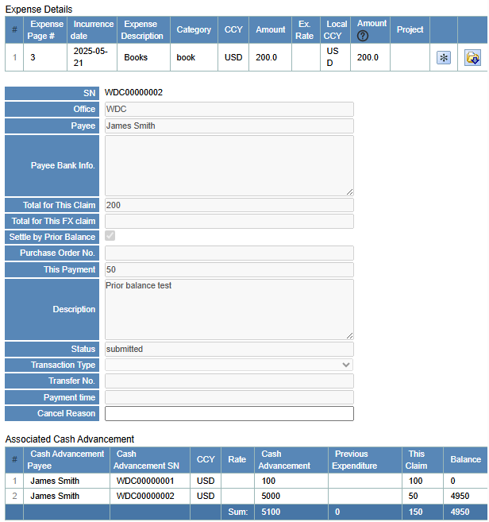

As seen in the figure above, the total amount for this claim is 200, with 50 to be paid in this transaction (“This Payment”). The Associated Cash Advancement table shows information about the relevant cash advancements, along with the amounts applied to this claim.

1. Approval process:

If the amount that needs to be paid is zero (i.e., fully covered by prior balance), and the setting **Enable automatic settlement upon approval** is enabled in **ES001G - Settings**, then the system will automatically mark the expense as Settled, and no further action is required from the finance staff.

If the amount to be paid is greater than zero, the finance staff will need to process the remaining payment.

For example, in this case, the finance staff needs to pay 50.

# Petty Expense

If an office has petty cash enabled in **ES001E - Petty Expense** (e.g., with a maximum amount of 500), then when submitting an expense in **ES004 - New Expense Details**, the claimer can choose to **Settle by Petty Cash**. After approval, the expense will be paid directly by the petty administrator, without requiring action from the finance staff.

**Steps to claim a petty expense:**

1. The petty administrator first applies for funds in **ES006 - Cash Advancement** to be used for petty expenses. Once approved, proceed to the next step.



1. The claimer fills out the expense in **ES004**, selects **Settle by Petty Cash** in the Expense Application Form, and submits the request.

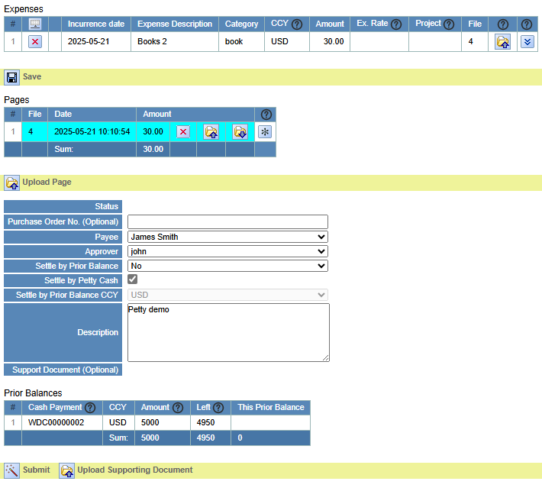

ES005 expense record:



1. The approver approves the expense in **ES005**.

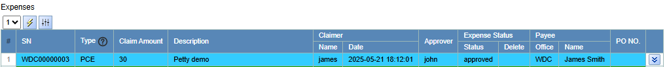

1. The petty administrator processes the payment in **ES005** by selecting Settle by Prior Balance, ensuring that the total amount equals the full expense amount.

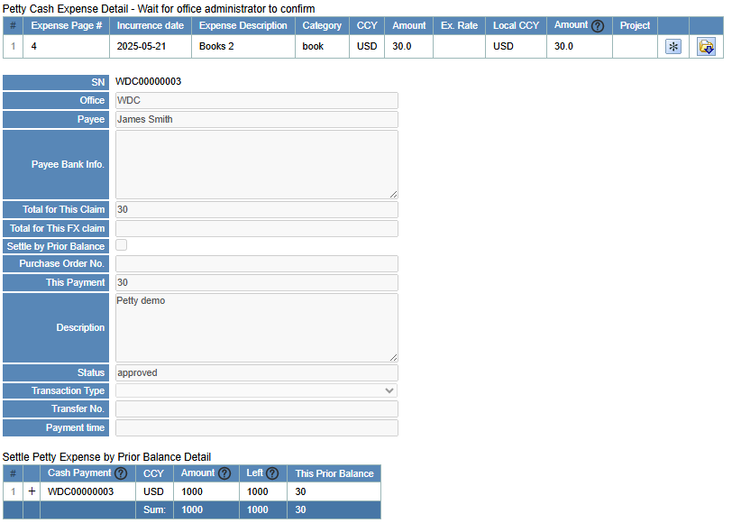

**As shown in the figure, the system will automatically populate the This Prior Balance value in the Settle Petty Expense by Prior Balance Detail table.  
If the prior balance amount is insufficient, the system will display a warning message.**

If the setting enable automatic settlement upon approval is enabled in **ES001G - Settings**, the system will automatically mark the expense as settled, and no further action is required from the finance staff.

If the expense is not automatically settled in the previous step, the finance staff must manually mark it as Settled in **ES005**.

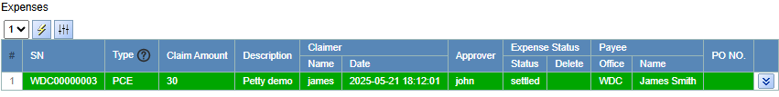

In **ES006 - Cash Advancement**, the petty administrator can review how the cash advancements have been utilized.

# ES101 - Expense Report

Use this report to view and download expense records by office and incurrence date range. Select the desired office and specify a date range to filter results. Click "Download" to export the data.

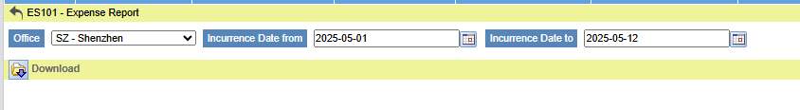

**Download contents:**

1. Expense Detail

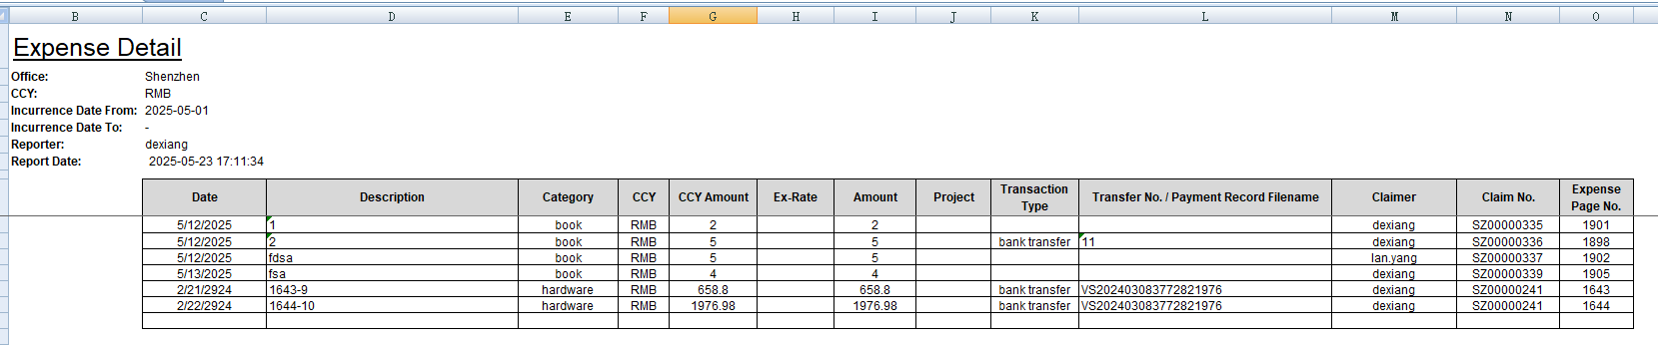

Reporter header field description:

|  |  |  |
| --- | --- | --- |
| # | Field | Description |
| 1 | Office | The office associated with the expenses |
| 2 | CCY | Currency code |
| 3 | Incurrence Date From/To | Range of expense incurrence dates |
| 4 | Reporter | The user who generated the report |
| 5 | Report Date | The date and time the report was generated |

Table column description:

|  |  |  |
| --- | --- | --- |
| # | Column Name | Description |
| 1 | Date | The date the expense was incurred |
| 2 | **Description** | Description or reason for the expense |
| 3 | Category | Type of expense |
| 4 | CCY | Currency of the expense |
| 5 | CCY Amount | Amount in original currency |
| 6 | Ex-Rate | Exchange rate used |
| 7 | Amount | Converted amount in the base currency |
| 8 | Project | Associated project |
| 9 | Transaction Type | Method of payment |
| 10 | Transfer No. / Payment Record Filename | Transfer ID or attached payment file reference |
| 11 | Claimer | Name of the person claiming the expense |
| 12 | Claim No. | Expense claim number |
| 13 | Expense Page No. | Reference to the physical or scanned page of the expense document |
| 14 | Cash Advancement SN | Serial number of cash advancement that used in this expense |

1. Payment Record File List

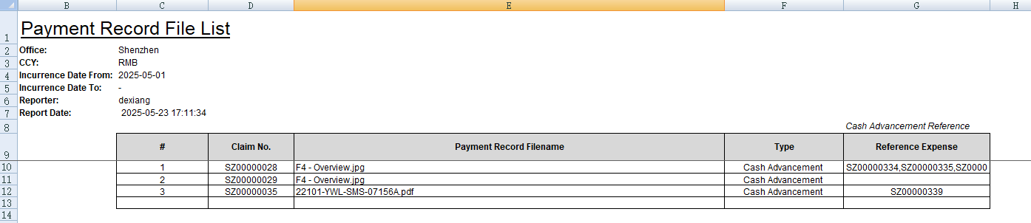

Reporter header field description:

|  |  |  |
| --- | --- | --- |
| # | Field | Description |
| 1 | Office | The office associated with the expenses (e.g., Shenzhen) |
| 2 | CCY | Currency code (e.g., RMB) |
| 3 | Incurrence Date From/To | Range of expense incurrence dates |
| 4 | Reporter | The user who generated the report |
| 5 | Report Date | The date and time the report was generated |

Table column description:

|  |  |  |
| --- | --- | --- |
| # | Column Name | Description |
| 1 | # | Row number |
| 2 | Claim No. | The unique identifier of the claim being processed |
| 3 | Payment Record Filename | The name of the uploaded attachment that supports the payment |
| 4 | Type | The category of the transaction |
| 5 | Reference Expense | The expense claim(s) that this payment relates to, listed by their Claim No. |

# ES102 - Cash Advancement Report

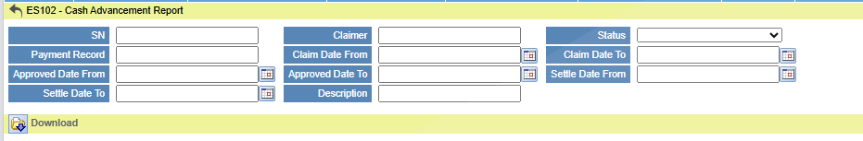

Use this report to view and download cash advancement report. Select the desired SN/ Claimer/Status/Payment Record/Claim Date Range/ Approved Date Range/ Settle Date Range/ Description to filter results. Click "Download" to export the data.

**Download contents:**

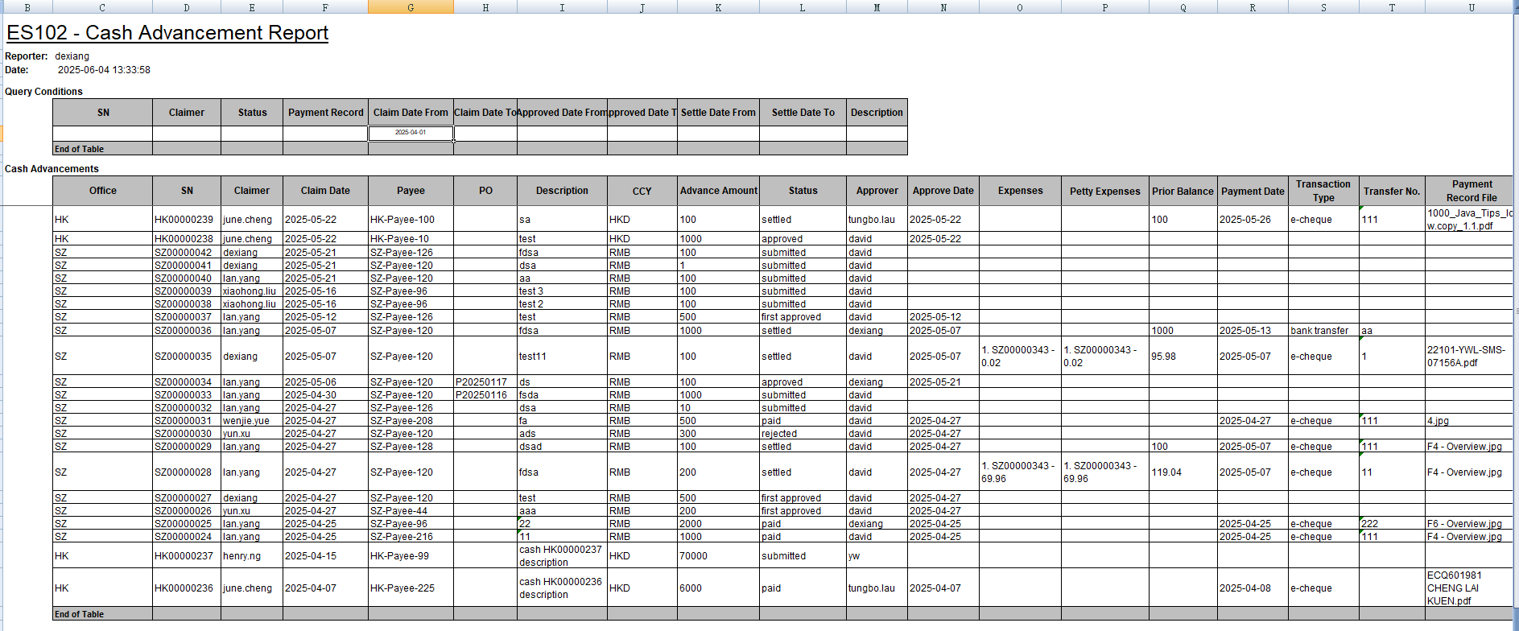

Reporter header field description:

|  |  |  |
| --- | --- | --- |
| # | Field | Description |
| 4 | Reporter | The user who generated the report |
| 5 | Date | The date and time the report was generated |

Query Conditions table column description:

|  |  |  |
| --- | --- | --- |
| # | Column Name | Description |
| 1 | SN | Serial number of cash advancement |
| 2 | Claimer | Submit claimer name |
| 3 | Status | Status of the advancement |
| 4 | Payment Record | Payment record file name |
| 5 | Claim Date From/To | Range of claim submit dates |
| 6 | Approved Date From/To | Range of cash advancement approved dates |
| 7 | Settle Date From/To | Range of cash advancement settled dates |
| 8 | Description | Description of cash advancement |

Cash Advancements table column description:

|  |  |  |
| --- | --- | --- |
| # | Column Name | Description |
| 2 | **Office** | The office for cash advancement |
| 3 | **SN** | Serial number of cash advancement |
| 4 | **Claimer** | Submit claimer name |
| 5 | **Claim Date** | Claimer submit date |
| 6 | **Payee** | The person or entity receiving the payment |
| 7 | **PO** | Purchase Order number associated with the request |
| 8 | **Description** | Description or reason for the cash advancement |
| 9 | CCY | Currency used for the transaction (e.g., HKD, RMB) |
| 10 | Advance Amount | The total amount of money requested in advance |
| 11 | Status | Current status of the claim (e.g., submitted, settled, rejected, paid) |
| 12 | Approver | The user who approved the cash advancement request |
| 13 | Approve Date | Date on which the request was approved |
| 14 | Expenses | Associated expenses reimbursed under this cash advancement |
| 15 | Petty Expenses | Amount from petty cash applied to this claim |
| 16 | Prior Balance | Prior balance |
| 17 | Payment Date | Actual payment processing date |
| 18 | Transaction Type | Mode of payment (e.g., bank transfer, e-cheque) |
| 19 | Transfer No. | Reference number of the payment transaction |
| 20 | Payment Record File | Filename to uploaded payment proof |

# PO001 - Purchase Order

## Overview

This page is used to create, search, and manage Purchase Orders (POs). Users can filter records based on different criteria and view history and status progress.

## Function Area Description

### Search Criteria Section



Users can enter filters here to search for specific purchase orders:

|  |  |  |
| --- | --- | --- |
| # | Field | Description |
| 1 | Po No | Enter the PO number for fuzzy search |
| 2 | Purchase Item/Reason | Enter item name or reason for fuzzy search |
| 3 | Office | Select the office from the dropdown |
| 4 | Status | Select PO status (Saved, Submitted, Approved, Rejected) |
| 5 | Submission Date From/To | Filter by the date range of submission |
| 6 | Approved/Rejected Date From/To | Filter by approval/rejection date |
| 7 | Submitter | Select the submitter |
| 8 | Approver | Select the approver |

Search Button: Click to execute the query based on entered criteria

### Status Legend



Color indicators for PO status:

* Yellow: Saved (Not submitted, visible to creator only)
* Light Blue: Submitted (Waiting for approval)
* Green: Approved (Successfully approved)
* Red: Rejected (Rejected)

### PO History Section

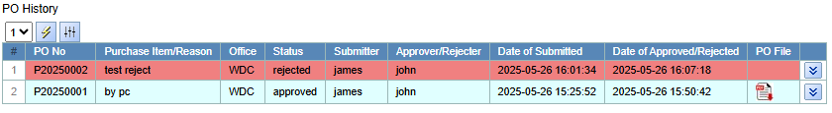

All matching records are displayed in a table format:

|  |  |  |
| --- | --- | --- |
| # | Column Name | Description |
| 1 | # | Row number |
| 2 | PO No | Purchase Order number. E.g. Pxxxxxx |
| 3 | Purchase Item/Reason | Item or reason for the purchase |
| 4 | Office | Associated office |
| 5 | Status | Current status (Saved/Submitted/Approved/Rejected) |
| 6 | Submitter | User who submitted the PO |
| 7 | Approver/Rejecter | User who approved or rejected |
| 8 | Date of Submitted | Date the PO was submitted |
| 9 | Date of Approved/Rejected | Date of approval or rejection |
| 10 | PO File | Display Signed PO file |

### PO Detail

This page allows users to create and submit a new Purchase Order (PO) for approval.

1. Purchase Information Section

|  |  |
| --- | --- |
| Field | Description |
| Office | Select the office associated with the purchase. This field is mandatory |
| Purchase Item/Reason | Enter the items to be purchased or the reason. Mandatory field |

1. Quotations Section

This is optional table

|  |  |
| --- | --- |
| Field | Description |
| # | Auto-generated row number |
| Vendor/Remark | Enter vendor details or remarks for each quotation |
| Price | Enter the quoted price |
|  | Upload file for this quotation (after saved) |
|  | Display file for this quotation |

1. Recommendation & Approval Section

|  |  |
| --- | --- |
| Field | Description |
| Recommendation | Optional field to input recommendation text |
| Approver | Select the user who will approve this PO. This field is mandatory. |

1. Status Tracking Fields (Auto-Populated)

These fields are automatically updated by the system and are read-only:

* Submitted By
* Submitted Date
* Approved By
* Approval Date
* Rejected By
* Rejected Date

1. Approval / Reject Remark

The remark for the approve operation is provided for submitter's reference. If it is a rejection operation, the remark is mandatory.

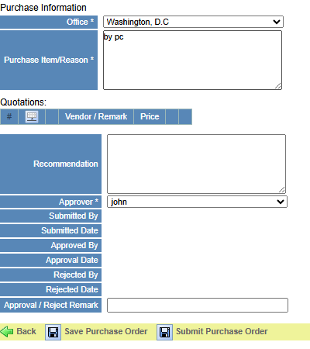

## Usage Process

### Create

User click “New” to create purchase order

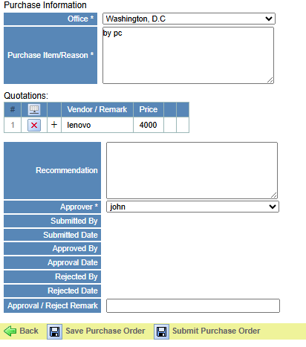

Quotations file requires creating quotation(s) and saving the PO before uploading the corresponding file

After filling in the information, the user can choose to save this PO and make modifications later. If choose to submit, it cannot be modified afterwards and will be transferred to approver for processing

After Submitted:

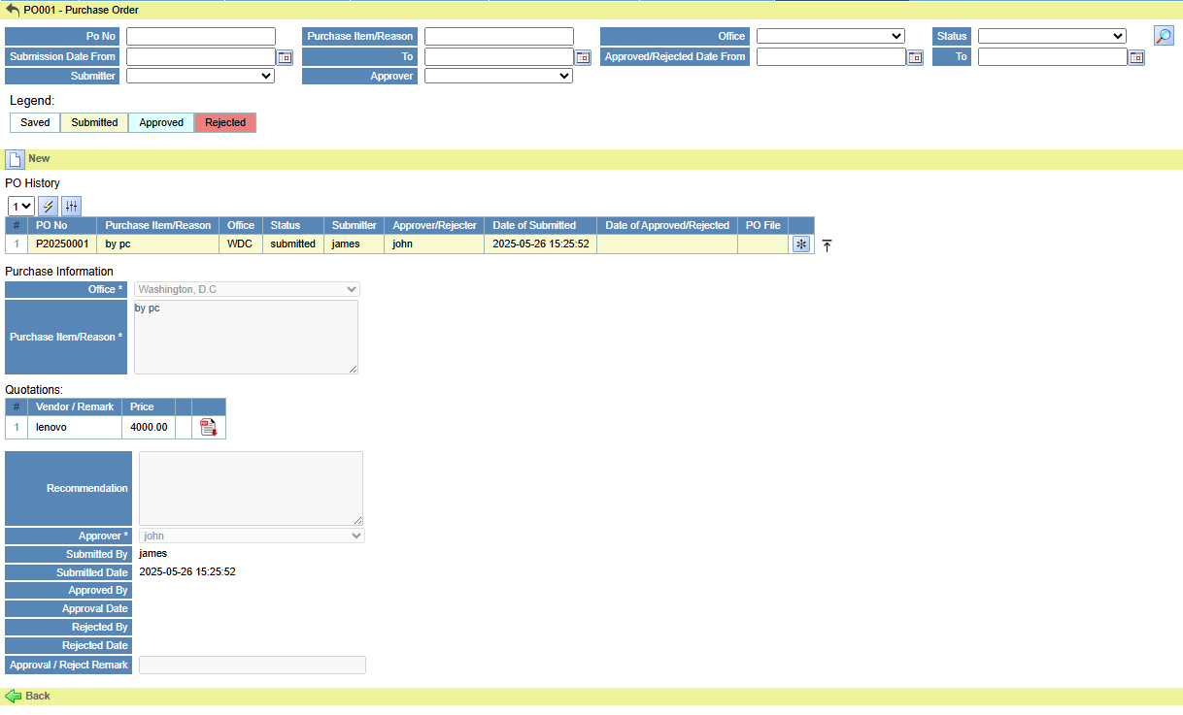

### Approve



Approver click  to Save or Approve or Reject this purchase order (here is a demonstration of user approval).

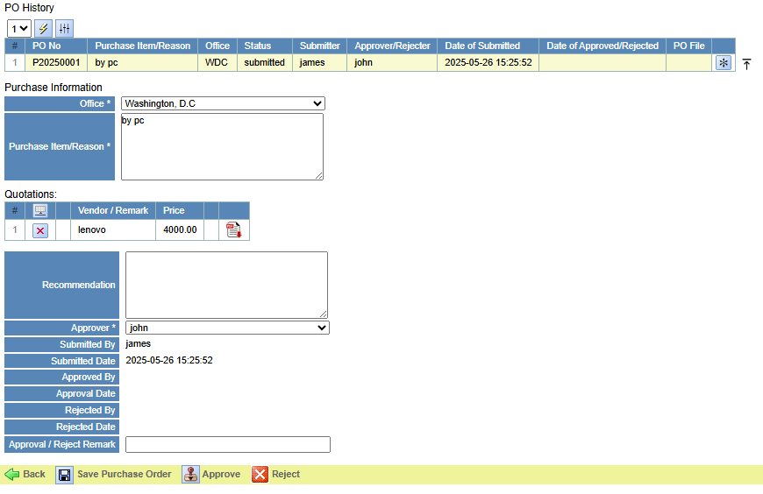

Approver click to approve this purchase order, will show a confirm dialog 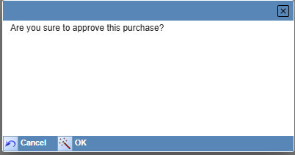 click 

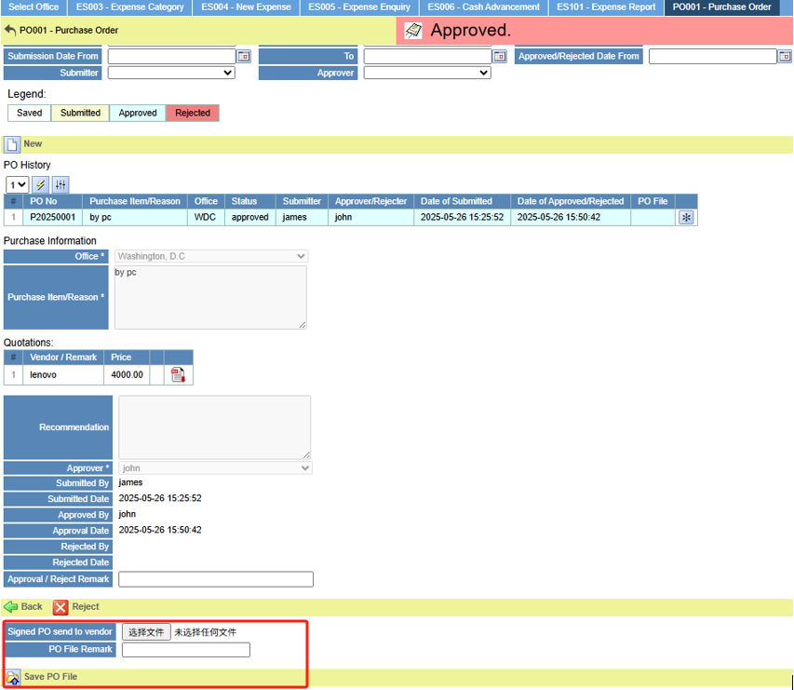

After the purchase order is approved, a "Signed PO" upload section will appear as above.

The approver can optionally upload signed PO files in this section.

If a signed PO file has been uploaded, a pdf button as blew will be available to open and view the file.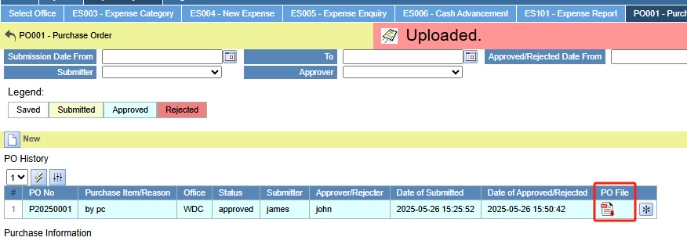

### Reject

Purchase orders in the Submitted/Approved status can be approved and rejected.

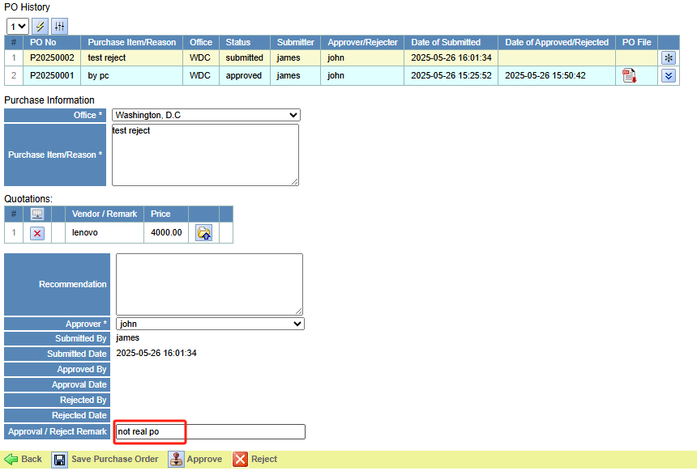

Approver must fill Remark for submitter’s reference before the reject operation can be performed.

Click  will show a confirm dialog.

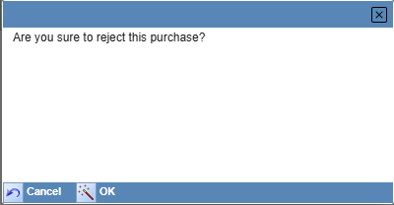 click 

After rejected: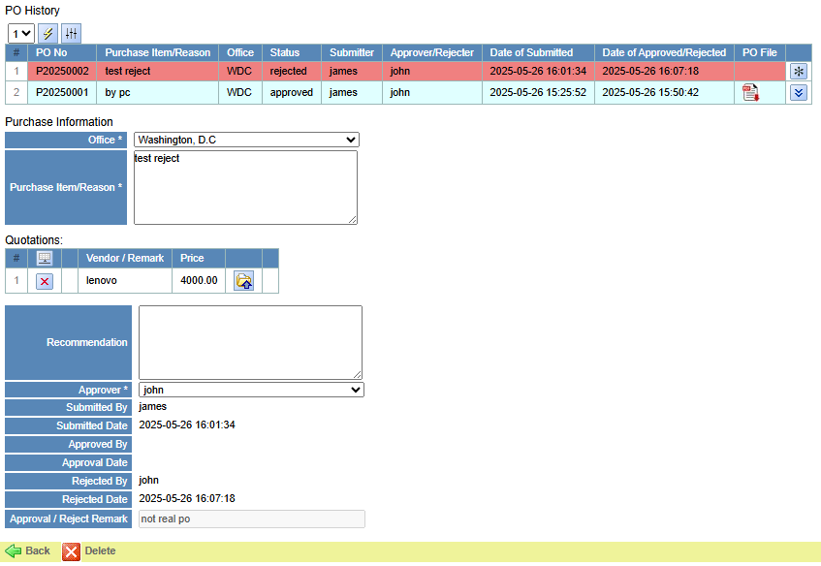

The approver's view is as above. Approver can delete the purchase order.

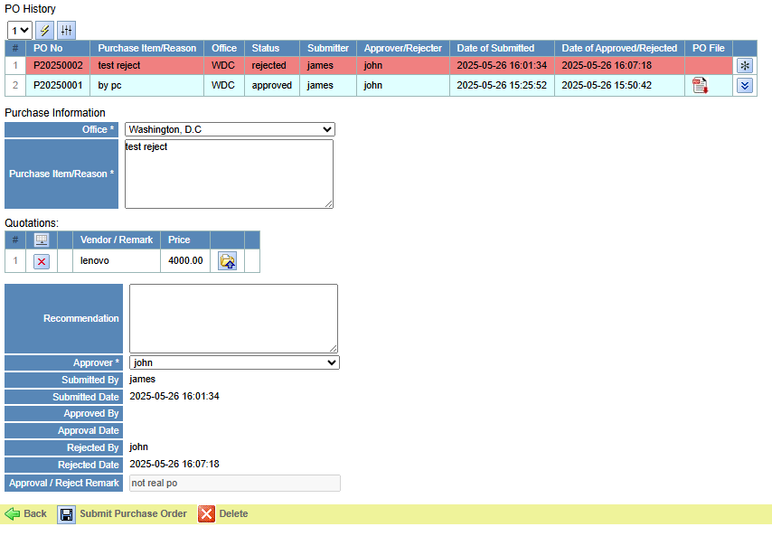

The submitter’s view is above. Submitter can edit & re-submit / delete this purchase order.

## Use Purchase Order

After the purchase order is approved, the submitter can apply the cash advancement for the purchase order in **ES006 - Cash Advancement**



P20250001 as shown in the above list has been approved and can be used to apply for cash advancement

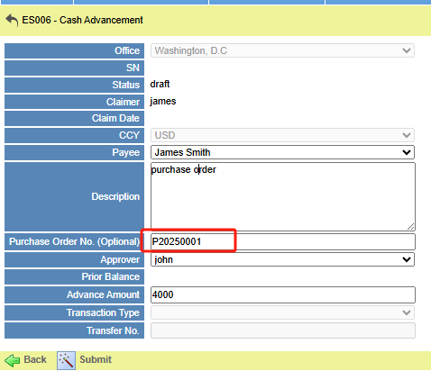

Fill in the correct PO No and Submit to create the correct cash advancement record for the purchase order application.

If the purchase no is filled in incorrectly or the corresponding purchase order status is not approved, it cannot be submitted correctly, and the system will prompt the corresponding error



The subsequent process is the same as **ES006 - Cash Advancement** operation.